Order Of Lenten Service

Opening Hymn: TLH 160

Reading: Lent VII

The History of the Passion of our Lord

Sermon Hymn: TLH 171 vs 1-6 (second version)

Sermon Text: Mark 5:35-43

Only Sleeping

Prayer

Holy Communion

The Lord's Prayer

The Blessing

Closing Hymn: TLH 171 vs 7-12

* * * * * * * * * * * * *

Bible Study: Lambs: Ovenbird
Sheep: Proverbs 17:11-15

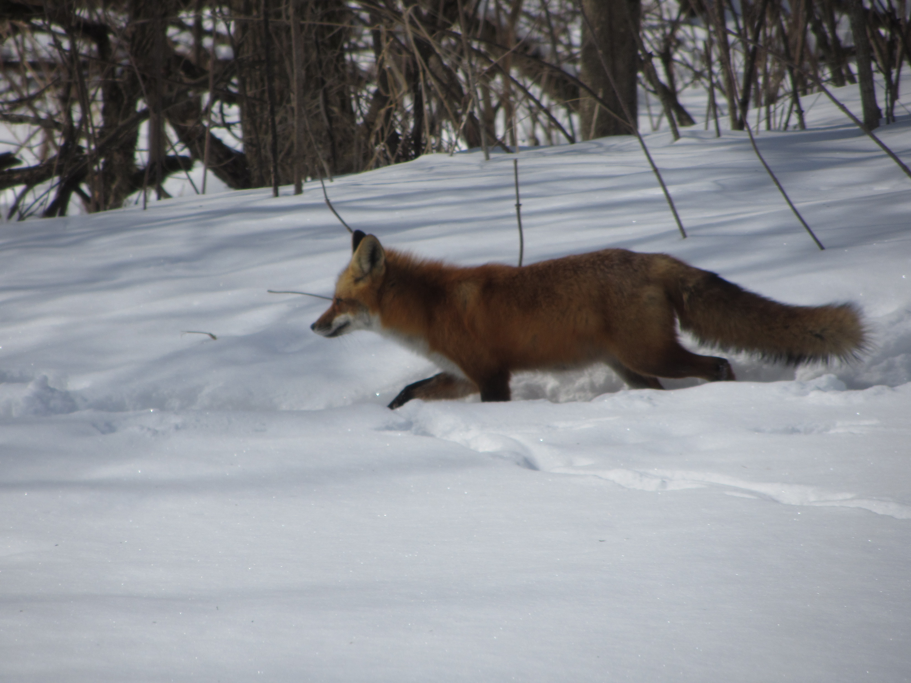

On The Move

Water
Of
Life

14 April 2019

W A T E R O F L I F E

Independent Christian Church—Conservative Lutheran Doctrine

Worship Service: 9:30 a.m. Bible Study: 10:45 a.m.

Larry Cooper, Pastor E-Mail address:
111 N. Ridge Road lcooper@wateroflife.cc
Coon Valley, WI 54623 Web Site:
www.wateroflife.cc

* * * * * * * * * * * * * * * * * * * * * * * * * * *

Sermon Text: Mark 5:35-43

Only Sleeping

* * * * * * * * * * * * * * * * * * * * * * * * * * *

Mark 5:35 While he yet spake, there came from the ruler of the synagogue's house certain which said, Thy daughter is dead: why troublest thou the Master any further?
:36 As soon as Jesus heard the word that was spoken, he saith unto the ruler of the synagogue, Be not afraid, only believe.
:37 And he suffered no man to follow him, save Peter, and James, and John the brother of James.
:38 And he cometh to the house of the ruler of the synagogue, and seeth the tumult, and them that wept and wailed greatly.
:39 And when he was come in, he saith unto them, Why make ye this ado, and weep? the damsel is not dead, but sleepeth.
:40 And they laughed him to scorn. But when he had put them all out, he taketh the father and the mother of the damsel, and them that were with him, and entereth in where the damsel was lying.
:41 And he took the damsel by the hand, and said unto her, Talitha cumi; which is, being interpreted, Damsel, I say unto thee, arise.
:42 And straightway the damsel arose, and walked; for she was of the age of twelve years. And they were astonished with a great astonishment.
:43 And he charged them straitly that no man should know it; and commanded that something should be given her to eat.





